Travel Information

Venue:
Colegio Arzobispo Fonseca, Universidad de Salamanca
(Archbishop Fonseca College, University of Salamanca)
Address: C/ Fonseca, 4 37002 Salamanca
Tel: +34 923 294 570
Fax: +34 923 294 645
E-mail: fonseca@usal.es

Map:
http://www.usal.es/webusal/en/mapa_localizacion/551

Access to Venue from Madrid-Barajas Airport:
By Bus
Airport to Salamanca: Avanzabus (approximately 3hrs.) The Madrid-Barajas bus stop is located at Terminal 1, in the car park opposite the arrivals lounge. Ticket sales and timetables are available on the Avanza Bus web page: www.avanzabus.com, at regular ticket counters and inside the airport itself, the Viajes de El Corte Inglés travel agency, located on the first of the Terminal building. Please click here for the Madrid-Barajas Airport – Salamanca time table.

The Salamanca bus station is located on Avenida Filiberto Villalobos, 71-85. Its location is very close to the heart of the city. From the bus stop to the symposium venue is approximately 10 min on foot, and 3 min by taxi.

By Train
RENFE (Spanish National Railways) provides daily services. To get to Madrid Chamartín Railway Station from Madrid-Barajas Airport, take underground line 8 to Nuevos Ministerios, and then change to line 10 which takes you to Chamartín. Time table and price can be found at their website.

Salamanca main train station is called "Salamanca train station" or "Vialia". There is also small station called "Salamanca-Alamedilla", which is closer to the city center; it is the first station when coming from Madrid, but note that trains do not depart from this station. To the symposium venue, it takes approximately 10 min from both Salamanca train station and Salamanca-Alamedilla station.

Transportation within Salamanca:
Salamanca is a laid-back, pedestrian city that can easily be discovered on foot. The best way to get around is with the city bus services or by walking.
You can consult the city bus services here (Spanish Only): http://www.gruporuiz.com/plantillas/salamanca/lineas.php

Map of Salamanca:
PDF

General Information:
- Time zone: +1 GMT
- Currency: Euro
- Electricity: 220volts; 50Hz; C-type plug.
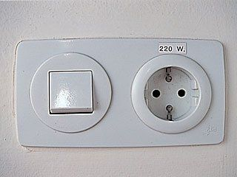
- Emergency numbers: General emergency services 112. Ambulance 061. Fire service 080.
- Telephone country code: (00)34
- Tipping: Spanish people aren't used to big tips, you can just leave a few coins and they are already more than happy with you.
*For more information on Salamanca and Spain, please visit: Spanish Town Guide

